**How to get my hook on your git repo**

To get the hook to work you need to download git desktop (bash).

Once that is done you can go to where your repos are stored and do a ‘git clone Your-Repo.git’.

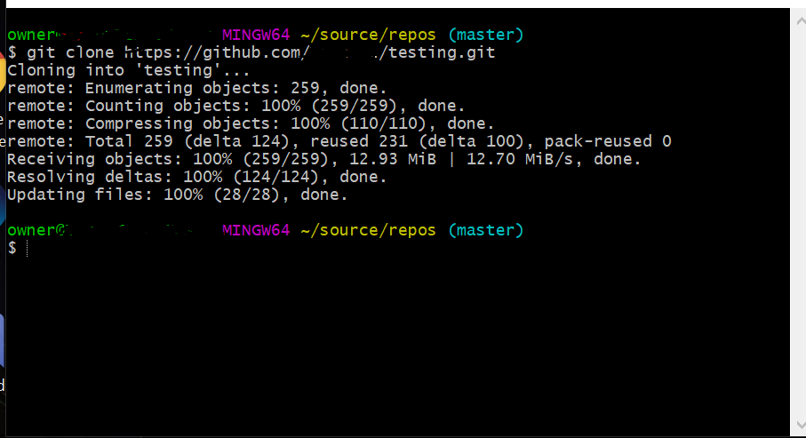

After that you can go into the repo ->.git -> hooks

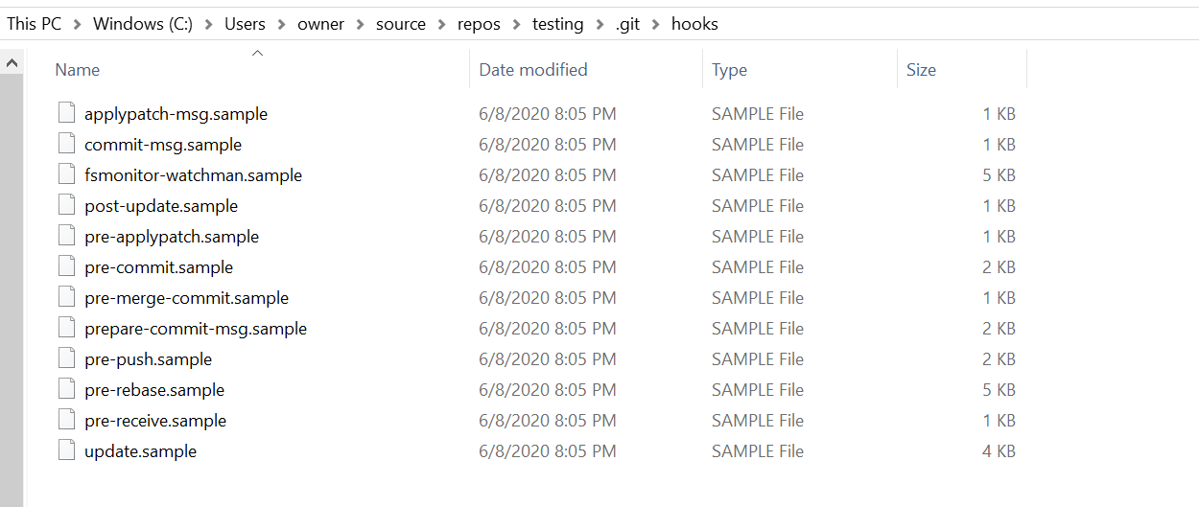

Right click in a blank area and do a new git bash here.

Type in the following commands:

‘ mv prepare-commit-msg.sample prepare-commit-msg’

‘ chmod +x prepare-commit-msg’

After that you need to copy and paste what I have written for the hook in my file deleting what is already in there, and whenever the program is committed it will make a file(if it doesn’t exist) and list their username and email. And for every commit after as well as the first commit how many lines added and deleted, what datetime it was committed, and a url link for a given commit.

**In Conclusion**

These steps can be similarly used to make your own git hooks, or change a git hook. You will just need to change the mv command to match the hook you are wanting to use.